**CS-232 - Intro to Database Management Systems**

**Assignment 0**

Ghulam Ishaq Khan Institute of Engineering Sciences & Technology, Topi, Swabi 23460,

Pakistan



**Portfolio Design using HTML/CSS**

**Members:**

* Raja Ata Ul Karim (2021528)
* M. Faizan Haq (2021368)

**Table of Contents:**

1. **Introduction Page. 3**
2. **Implementation Page. 4**
3. **Home Page Page. 5**
4. **About Page Page. 7**
5. **Services Page Page. 9**
6. **Contact Page Page. 11**

**Introduction:**

Initially, the group members decided to create a website that encompassed only coding-related stuff for clients. However, it was decided that the website will be based on one of the member’s real-life portfolios, which would include most of their experiences throughout their career.

To implement the design, instead of using Figma or Adobe Experience Design, the members decided just to create a schema using Photoshop.

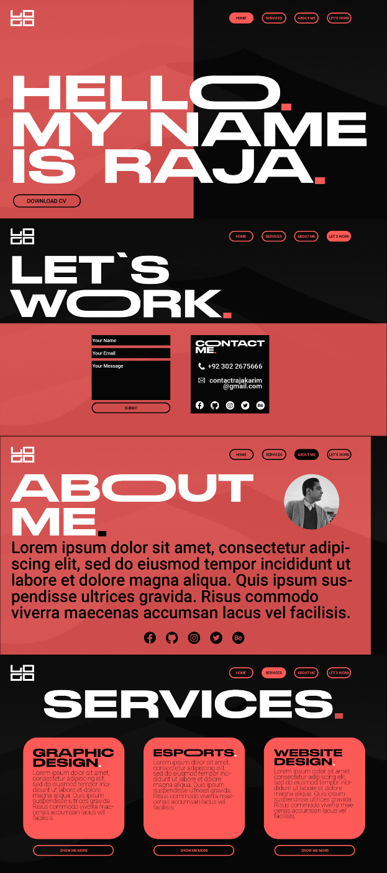Attached below are the initial website designs, created in Photoshop:

**Implementation:**

In the Implementation Phase, the Group Members faced a lot of challenges in terms of pushing for replicating the design created in Photoshop. However, it was decided that adjustments to the cosmetics will be made for ease of design in HTML/CSS.

No external programs were used to implement the website, however, external APIs were used, Mainly Google Fonts and Font-Awesome.

**Portfolio Design:**

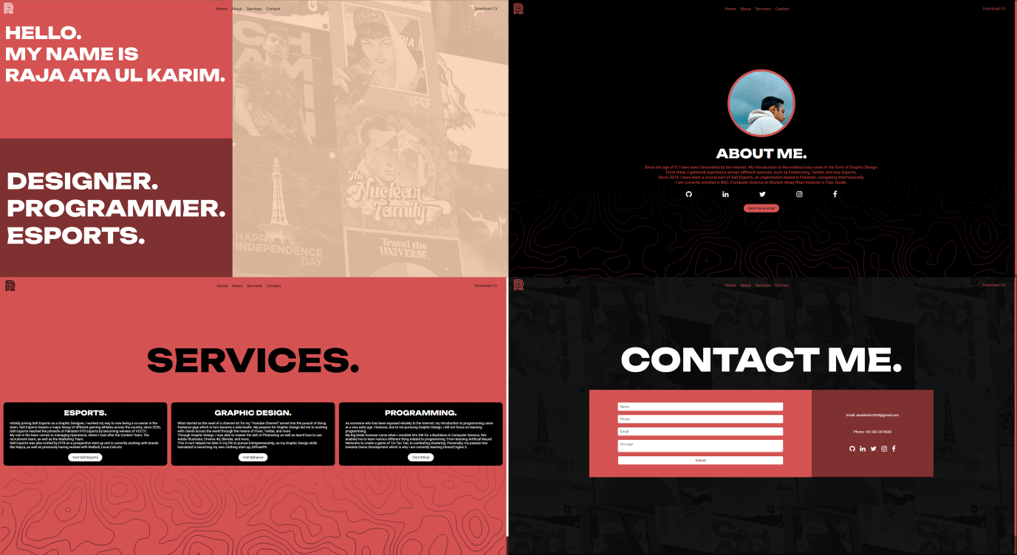

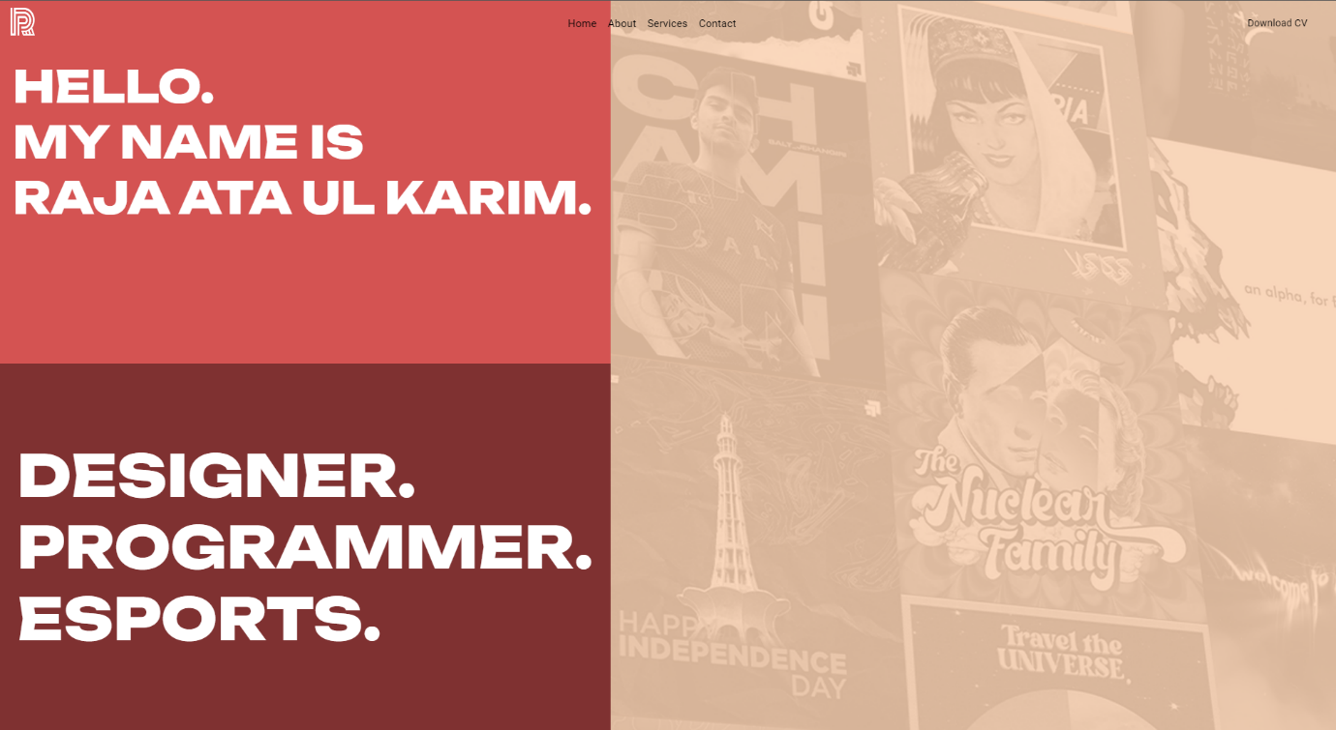**Home Page:**

**HTML:**

 <header>

            <nav class="navbar">

              <a href="home.html" class="navbar-brand">

                <img src="/Assets/My Logo.png" alt="Logo">

              </a>

              <ul class="navbar-nav">

                <li class="nav-item">

                  <a href="home.html" class="nav-link">Home</a>

                </li>

                <li class="nav-item">

                  <a href="about.html" class="nav-link">About</a>

                </li>

                <li class="nav-item">

                  <a href="services.html" class="nav-link">Services</a>

                </li>

                <li class="nav-item">

                    <a href="contact.html" class="nav-link">Contact</a>

                </li>

               </ul>

               <a href="/Assets/Raja Ata Ul Karim - Esports CV.pdf" download="Raja Ata Ul Karim - CV" class="button">Download CV</a>

            </nav>

        </header>

<div class="container">

            <div class="left-rect">

              <div class="left-upper-rectangle">

                <p class="write-text">HELLO. <br /> MY NAME IS <br/>RAJA ATA UL KARIM.</p>

              </div>

              <div class="left-bottom-rectangle">

                <p class="text-small">

                  DESIGNER.

                  <br/>PROGRAMMER.

                  <br/>ESPORTS.

                </p>

              </div>

            </div>

            <div class="right-rectangle"></div>

        </div>

}

**About Page:**

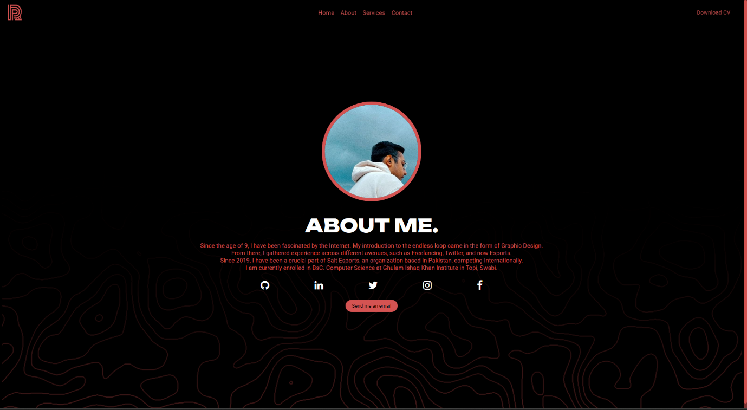**HTML:**

<div class="container">

      <img src="/Assets/profile.jpg" class="profile-picture">

      <h1 class="title">ABOUT ME.</h1>

      <p class="description">

        Since the age of 9, I have been fascinated by the Internet. My introduction to the endless loop came in the form of Graphic Design.

        <br/> From there, I gathered experience across different avenues, such as Freelancing, Twitter, and now Esports.

        <br/> Since 2019, I have been a crucial part of Salt Esports, an organization based in Pakistan, competing Internationally.

        <br/> I am currently enrolled in BsC. Computer Science at Ghulam Ishaq Khan Institute in Topi, Swabi.

      </p>

      <div class="social-media-icons">

        <a href="https://github.com/r2ja" target="_blank">

          <i class="fa fa-github fa-2x"></i>

        </a>

        <a href="https://linkedin.com/in/rajaataulkarim" target="_blank">

          <i class="fa fa-linkedin fa-2x"></i>

        </a>

        <a href="https://twitter.com/r4ja_" target="_blank">

          <i class="fa fa-twitter fa-2x"></i>

        </a>

        <a href="https://instagram.com/rajaataulkarim" target="_blank">

          <i class="fa fa-instagram fa-2x"></i>

        </a>

        <a href="https://facebook.com/imrajakarim" target="_blank">

          <i class="fa fa-facebook fa-2x"></i>

        </a>

      </div>

      <a href="mailto:ataulkarim2003@gmail.com" class="buttn">Send me an email</a>

    </div>

**Services Page:**

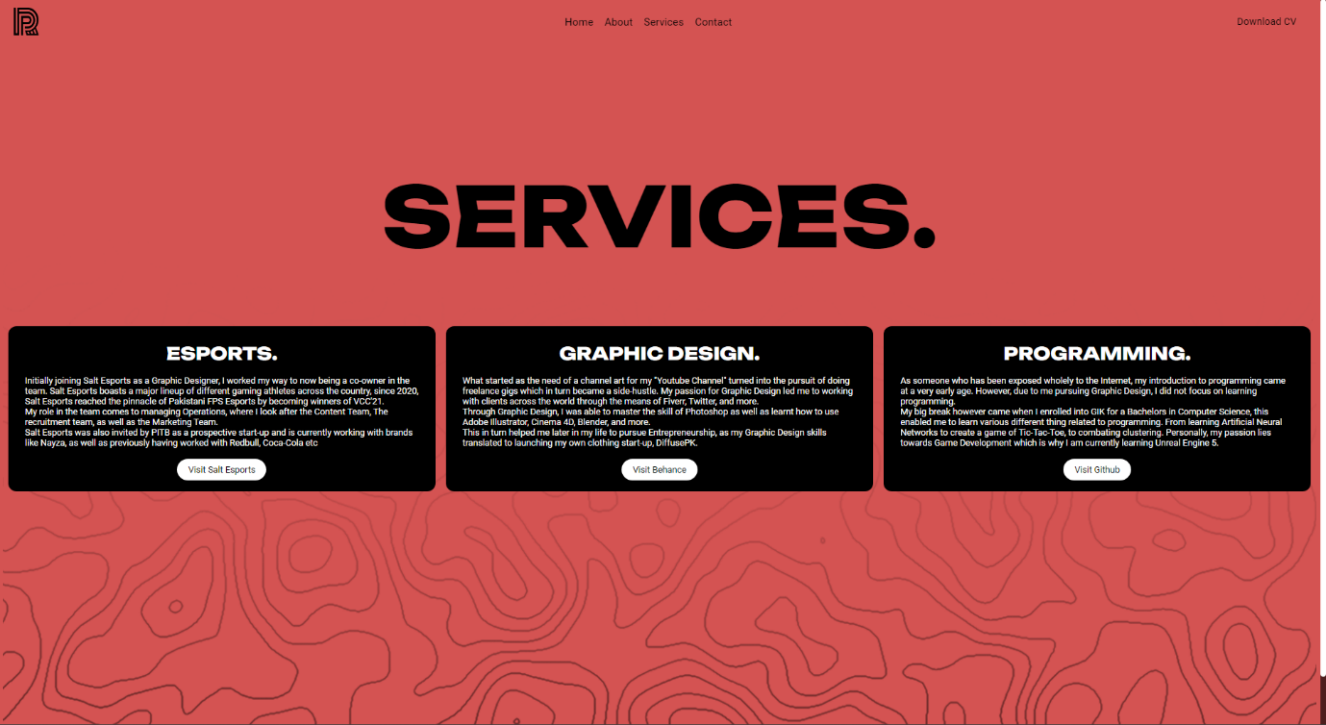**HTML:**

<h1 class="center">SERVICES.</h1>

        <div class="container">

          <div class="service">

            <div class="service-title">ESPORTS.</div>

            <p class="service-description">Initially joining Salt Esports as a Graphic Designer, I worked my way to now being a co-owner in the team.

                Salt Esports boasts a major lineup of different gaming athletes across the country, since 2020, Salt Esports reached the pinnacle of Pakistani FPS Esports

            by becoming winners of VCC'21.

            <br/> My role in the team comes to managing Operations, where I look after the Content Team, The recruitment team, as well as the Marketing Team.

            <br/> Salt Esports was also invited by PITB as a prospective start-up and is currently working with brands like Nayza, as well as previously having worked

            with Redbull, Coca-Cola etc  </p>

            <a href="https://www.instagram.com/saltesports_/" class="buttn">Visit Salt Esports</a>

          </div>

          <div class="service">

            <div class="service-title">GRAPHIC DESIGN.</div>

            <p class="service-description">What started as the need of a channel art for my "Youtube Channel" turned into the pursuit of doing freelance gigs which in turn

                became a side-hustle. My passion for Graphic Design led me to working with clients across the world through the means of Fiverr, Twitter, and more.

                <br/>Through Graphic Design, I was able to master the skill of Photoshop as well as learnt how to use Adobe Illustrator, Cinema 4D, Blender, and more.

                <br/>This in turn helped me later in my life to pursue Entrepreneurship, as my Graphic Design skills translated to launching my own clothing start-up, DiffusePK.</p>

            <a href="https://behance.net/imrajakarim" class="buttn">Visit Behance</a>

          </div>

          <div class="service">

            <div class="service-title">PROGRAMMING.</div>

            <p class="service-description">As someone who has been exposed wholely to the Internet, my introduction to programming came at a very early age. However, due to me

                pursuing Graphic Design, I did not focus on learning programming.

                <br/> My big break however came when I enrolled into GIK for a Bachelors in Computer Science, this enabled me to learn various different thing related to

                programming. From learning Artificial Neural Networks to create a game of Tic-Tac-Toe, to combating clustering. Personally, my passion lies towards Game Development

                which is why I am currently learning Unreal Engine 5.

            </p>

            <a href="https://github.com/r2ja" class="buttn">Visit Github</a>

          </div>

        </div>

**Contact Page:**

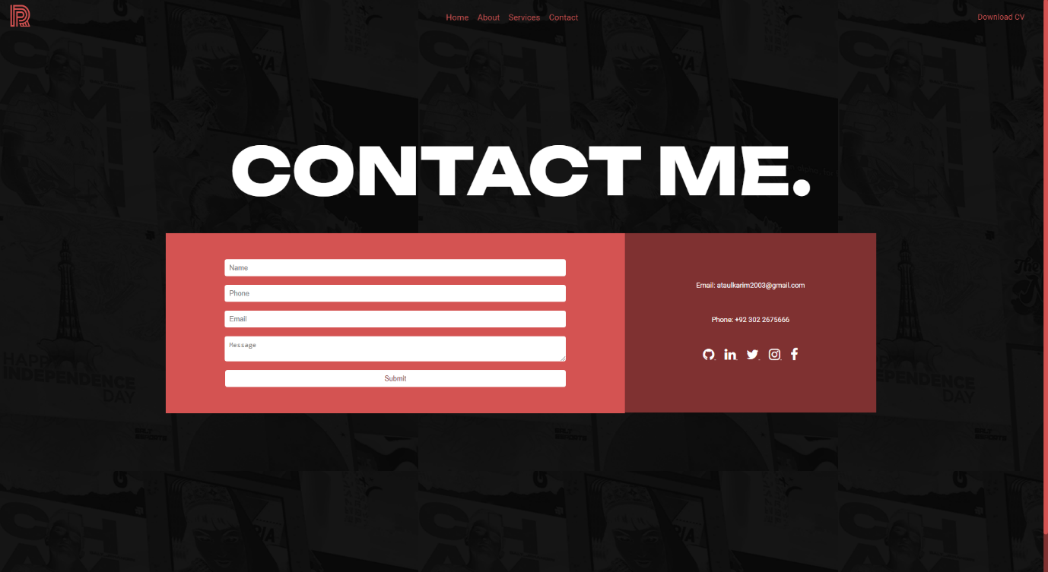**HTML:**

<h1 class="center">CONTACT ME.</h1>

  <div class="container">

    <div class="left-container">

      <form action="mailto:ataulkarim2003@gmail.com" method="post">

        <input type="text" name="name" placeholder="Name">

        <input type="tel" name="phone" placeholder="Phone">

        <input type="email" name="email" placeholder="Email">

        <textarea name="message" placeholder="Message"></textarea>

        <input type="submit" value="Submit">

      </form>

    </div>

    <div class="right-container">

      <p>Email: ataulkarim2003@gmail.com</p>

      <p>Phone: +92 302 2675666</p>

**Extra (Favicon):**

<link rel="shortcut icon" type="image/png" href="/Assets/favicon.png">